Ideation Phase
Brainstorm & Idea Prioritization

Date | 27 September 2026
Team ID | SWTID-2026-7148
Project Name | AI Weatherwise API
Maximum Marks | 4 Marks

Brainstorm & Idea Prioritization
For the AI Weatherwise API project, the team conducted a brainstorming session to identify different solutions for improving weather information and user experience. The team encouraged multiple ideas such as real-time weather updates, AI-based weather prediction, personalized weather insights, weather alerts, location-based forecasts and developer-friendly API integration. The generated ideas were listed, discussed and grouped based on their functionality to identify suitable solutions for the project.
Step-1: Team Gathering, Collaboration and Select the Problem Statement
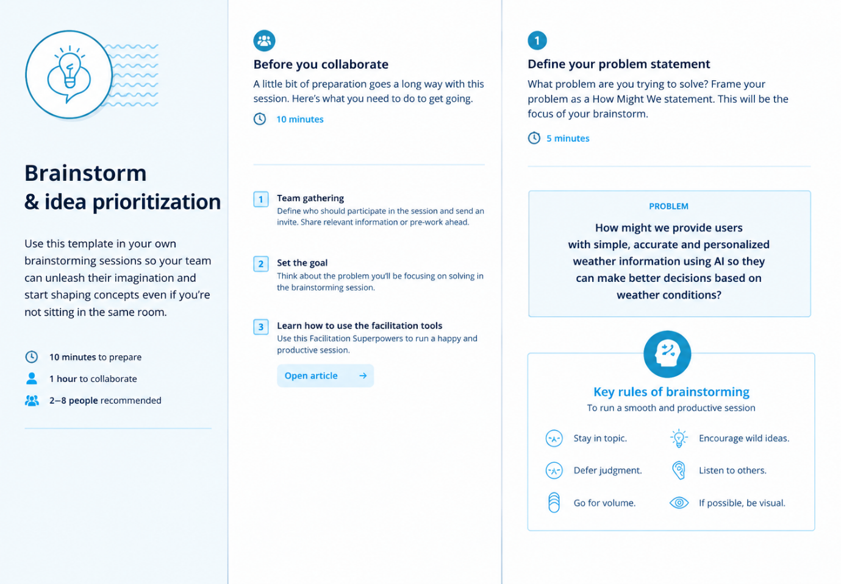

Step-2: Brainstorm, Idea Listing and Grouping

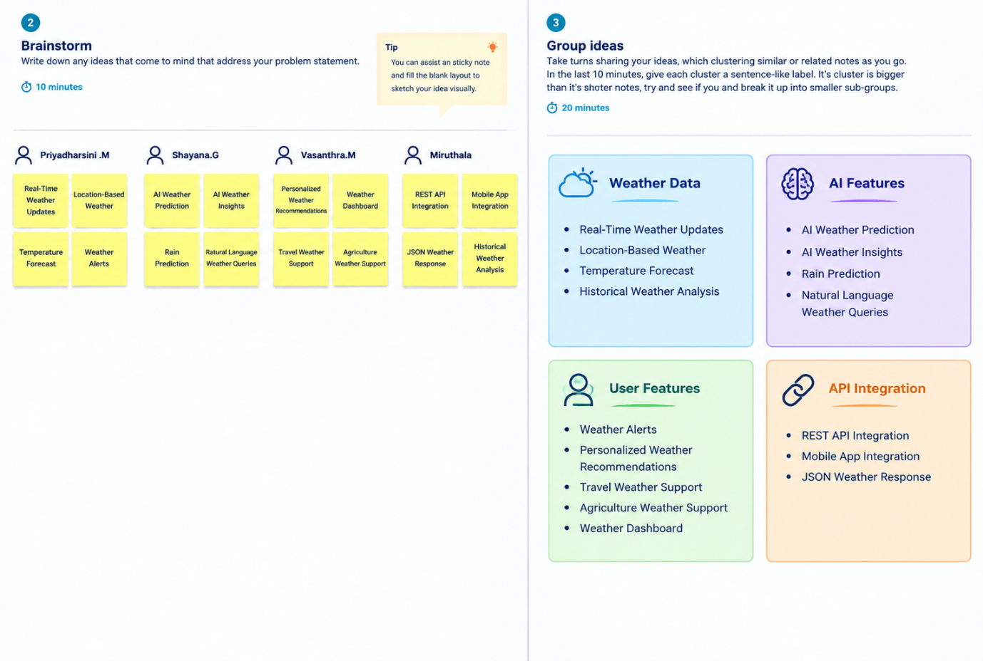
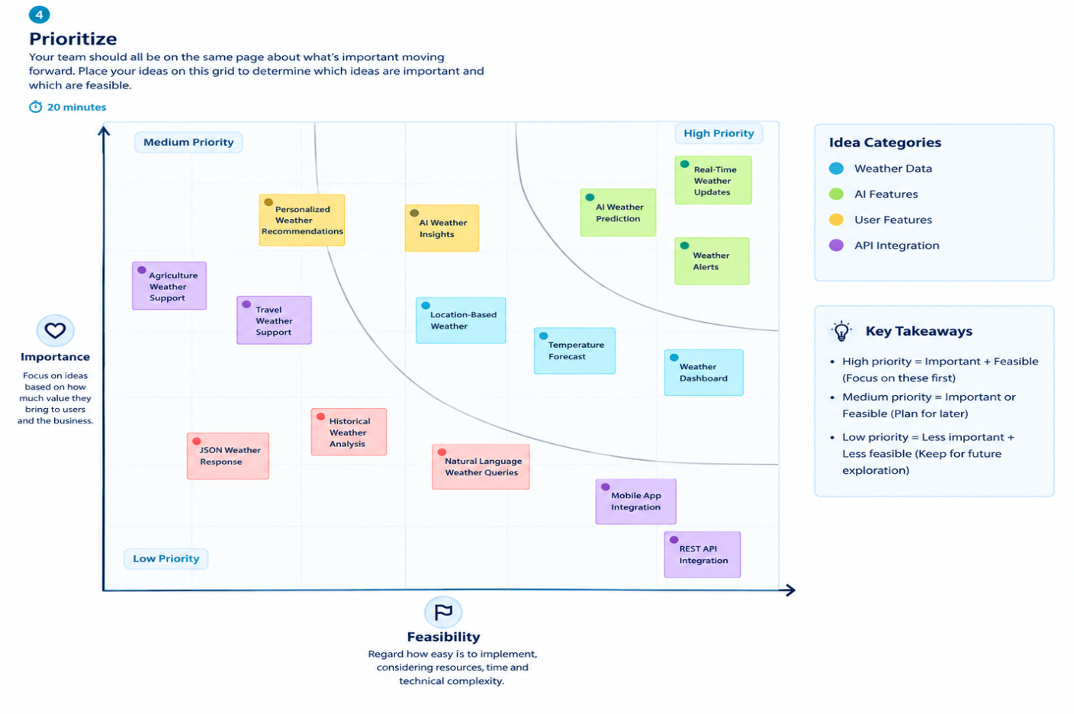
Step-3: Idea Prioritization

